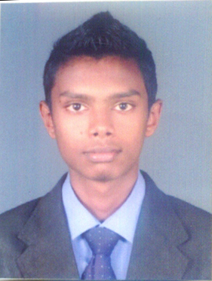**CURRICULAM VITAE**

**MOHAMMED ZAMEER FAWZER**

* Doha Qatar
* Mobile: +974 5072 9619
* Skype ID: zameerfawzer
* E-mail: [zameerfawzer@gmail.com](mailto:zameerfawzer@gmail.com)
* Visa status: Transferrable visa with NOC

OBJECTIVE

“A hard working and reliable Professional seeking a challenging Position with a dynamic and progressive Organization. An Opportunity to contribute to the success of the firm while developing valuable business Skills”.

WORKING EXPERIENCE

**ABANS (PVT) LTD (JAN 2014 – OCT 2016)**

“Abans PLC, is a Market leader in electronics, mobiles and home appliances in Sri Lanka which Introduced Korean Technology to Sri Lankan Consumers. Listed in Colombo Stock Exchange. Work More than 4000 Employees”.

***Sales Executive***

* Provide superior customer service and solutions by delivering products and services to meet or exceed customer expectations.
* Build strong customer relationships, loyalty and retention
* Actively engage Anixter colleagues and resources regularly to provide a complete customer solution in order to capitalize on opportunities.
* Establish or identify prices of goods, services or admission, and tabulate bills using calculators, cash registers, or optical price scanners.
* Resolve customer complaints.
* Answer customers' questions, and provide information on procedures or policies.
* Controlling the income and outcome Goods
* Identifying what customers want
* Responsible for promoting the good image of the organization

KEY SKILLS AND COMPETENCIES

* Proficient in Microsoft Office
* Actively working as a member of a team
* Organizing and planning skills
* Excellent customer service and communication skills.
* Upholding individual performance targets.
* Reliable, punctual, professional and competent.
* Good numerical and literacy skills and can work accurately within deadlines.
* Pro-active and able to multi-task.
* Sales knowledge of Electronic and Smart Mobile Products

PROFESSIONAL QUALIFICATION

* I.G.C.S.E (LONDON) O/L Examination
* IELTS (Academic) 5.5

LANGUAGE PROFICIENCY

* Excellent command of English.

PERSONAL DETAILS

* **Full name :** Mohammed Fawzer Mohammed Zameer
* **Current Address** **:** Doha, Qatar.
* **Date of Birth** **:** 20th April 1995
* **Civil Status** **:** Single
* **Nationality** **:** Sri Lankan
* **Passport number** **:** N6773116
* **Gender :** Male

I declare that the above particulars that I have given to you are true and correct to best of my knowledge. I would be pleased to give you any further information if required.   
  
I believe my qualification will enable me to successfully assume the responsibilities of the post at your organization.

Zameer Fawzer